***Belloui Labradoodles Shopping List***

There are some essential items you will need to purchase for your new puppy. Most of these can be purchased at places like **Petbarn,** **Petstock,** **World** **For** **Pets** and other big pet stores. Some things can be found online ie **Petcircle & Vebo Pets**, you can shop around to find cheaper items, just be careful of inferior products.

***Grooming***

Steel comb

Slicker brush

Shampoo and conditioner ie Alloveen Oatmeal

***Food***

Lyka dog food, is a subscription and only avail online. There is a discount code on our website for your first box.

<https://www.bellouilabradoodles.com/food>

Petzyo – Salmon and Ocean Fish.

Raw chicken wings, frames, turkey wings, kangaroo, beef and brisket bones.

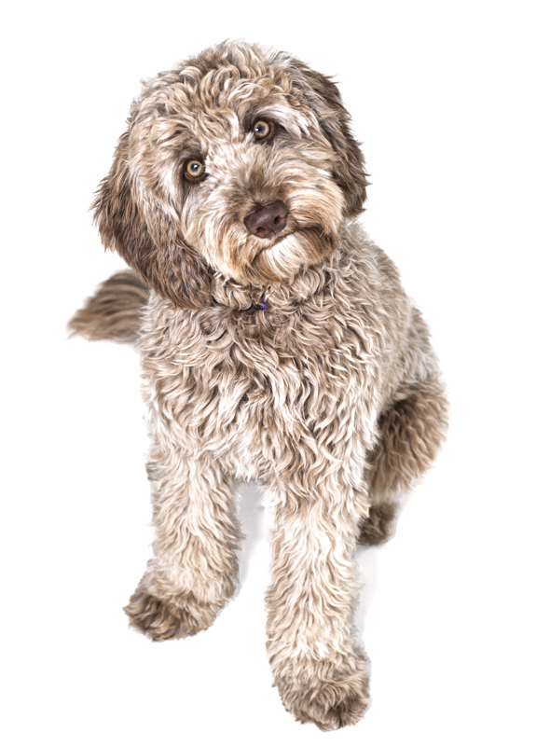Grated raw veggies: sweet potato, zucchini, blueberries and pumpkin.

Tinned sardines and tuna, cheese, natural yogurt, eggs & bone broth

***Bedding***

Crate with cover & divider – Vebo Pets

Fencing to create penned area around crate

Soft dog beds for around the house/inside crate

***Other Items***

Collar & Lead

Small harness and car seatbelt or travel crate

Flea/tick/worm products – monthly spot on treatments, Bravecto,

Sentinel, Comfortis, Advantage or Nextgard

Water and food bowls

Toys, tugs, chews – Kong brand is very reliable.

Food/treat dispensers – Kong

Treats – pig ears, dehydrated meat – try to keep treats as natural as possible.

Treat pouch

Pee pads

It’s a good idea to book your puppy in to start puppy preschool now, so they can start as soon as they come home.

Any questions please don’t hesitate to ask

Nicole Goggins: 0404 871 815

[bellouilabradoodles@gmail.com](mailto:bellouilabradoodles@gmail.com)

https://www.facebook.com/bellouilabradoodles

<https://www.instagram.com/belloui_labradoodles/>

<https://www.bellouilabradoodles.com/>